If… Then- Writing Informational Books 6-8
Session Number | Connection…  Teaching Point-Mini Lesson-  “Today I want to teach you…” | Teach  Watch Me As I…  Model the instruction you want them to use...  “Watch me as I…” | Mentor Texts & Chart or Materials | Active Engagement- Turn & Talk-  “Did you see how I just did that? Turn to your partner and….” | Link  Today we worked on…. So when you go off and write,, try to…  “Off you go” | Mid Workshop & Share Session-  End of Workshop  “So our workshop for today is ending... Today we worked on…, this is important all of the time when you write informational topics….” Off you go!
 |  | Bend I: Drafting and Revising to Teach What You Know
1- Considering Different Structures | Connection: “Today I want to teach you…”…that writing an informational book is similar to teaching- and one of the things a teacher does is break down a topic into smaller topics, so it is easier for the learner to grasp the content. Teachers and writers, both try to think of a logical way to organize the information for learners. | Teach: Suppose I was writing a book on gardening…I might structure with an order that starts with planting, then fertilizing, weeding… and finally harvesting.  If I were writing about Dogs, I could have chapters like, Collies, Beagles, Bulldogs… like a list that maybe went from the most common dogs to least common, like a ranked list. Or… if I were writing about the good things about dogs as pets, and the bad things, it might be organized by Pros and Cons. (Show the text structure chart while you demonstrate)  Watch how I planned out my sections on Pandemics. I thought I would teach a bit about what pandemics are, and the history of pandemics in the US. | 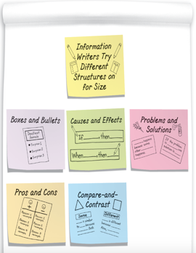  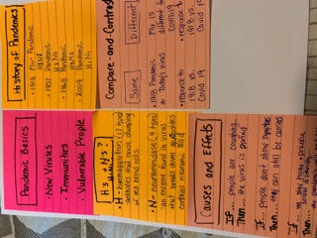  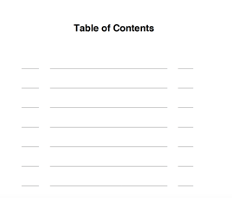  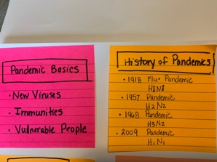 | AE: Let’s think about a topic that you can all imagine different ways to structure…”The History of Pandemics” Some might use Boxes and Bullets to show the different types of pandemics and the details around them. Another way to structure this topic might be Compare and Contrast the past pandemics to this current virus. One more structure might be problem and solution to describe all that happened in the country to deal with the pandemic. | Link: So when you go off to write about your informational topic, try several different ways to structure your piece before you actually start. This will help you know what structure might be best as you work to include details to write a good deal of text. | Mid TP- “Writers.. can I have your attention for a moment? Once you have your chapter titles written, you might want to jot some notes under each title to make sure you know the details that you’ll include in that chapter. This will also help you see whether you have enough to make up a full chapter of writing, or if some topics might need to be broken into more than one chapter.  Share- Consider which chapter you’ll write first, thinking about teaching your topic to a reader, you’ll want to choose a topic that will be a good start to your teaching. When you talk to a partner, share which chapter you’ll begin with, and teach a bit from what will be the beginning of your informational books. Try to start writing a bit under the first chapter tonight, and you’ll be ready to add to it tomorrow.
2. -Studying Qualities of Good Information Writing to Write Well, Right From the Start | Connection: Now that you’ve decided how you want to organize, or structure, your writing, you’ll be ready to begin drafting today. Today I want to teach you that although information writers are mostly putting information on to the page so others can learn from it, their goal is to write in ways that get through to their readers, thinking “How can I make this really good?” | Teach: Let’s look at one of Seymour Simon’s books on Space. What do you notice about this book and some of the things he did as a writer?  Qualities of Good Informational Writing  -Sections are focused on one topic  - Has ideas, not just facts  -Includes a variety of examples such as stories, quotes, and statistics  - Used “expert” language: words & phrases that are important to the topic  - Taught information with words, images, captions, and charts | 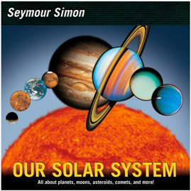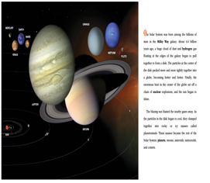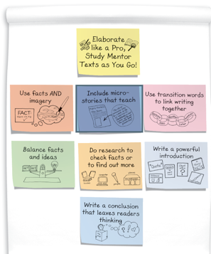 | AE: Think about what you’re going to write today for your non-fiction chapter. Try to consider all you can put into your writing, similar to what we listed from other NF books. | Link: You have probably started Chapter 1 and maybe you have a half page of writing so far. Today… try to make that chapter at least two pages long and see if you can finish it today. Try to incorporate as many of the qualities as you can. “off you go!” | Share- Today, before we wrap up, I’d like you to go back and reread what you have written so far… really looking at what’s on the page and make any revisions for edits to make your writing even easier to read. Tomorrow we’ll do some work with the checklist to set some goals to improve our writing.
Session Number | Connection…  Teaching Point-Mini Lesson-  “Today I want to teach you…” | Teach  Watch Me As I…  Model the instruction you want them to use...  “Watch me as I…” | Mentor Texts & Chart or Materials | Active Engagement- Turn & Talk-  “Did you see how I just did that? Turn to your partner and….” | Link  Today we worked on…. So when you go off and write,, try to…  “Off you go” | Mid Workshop & Share Session-  End of Workshop  “So our workshop for today is ending.. Today we worked on…, this is important all of the time when you write informational topics….” Off you go!
3-Working on Self-Assessment, Goal-Setting and Revision | Connection: So you have your first chapter finished, and now it’s a good time to draw on all you know about good writing. You’re going to use the informational checklist today to self-assess your writing and make it even better. This is the checklist from last year, and you should be able to use it to make sure your writing is where it should be. We haven’t covered everything in 6th grade yet….  “Today…. That a good coach is hard on his or her players, and they push them to always to their best work. A good coach doesn’t say, “Well, you kind of did that, so you may as well check yes.” No… a good coach has high expectations and doesn’t step back from that. | Teach: What you’ll want to do today is really look at the checklist, and then your writing, and then set some goals for what you can do to improve your writing. When I look at another NF book, it might help me to see how the author did it, and then try that in my own writing. | 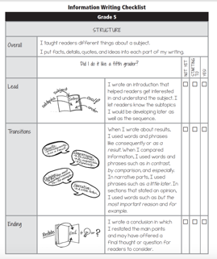  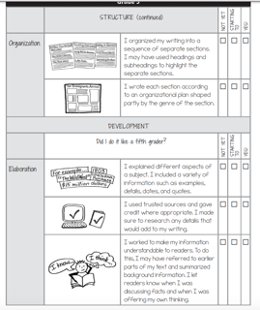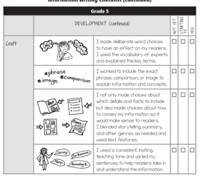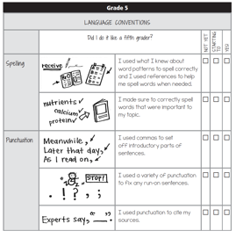 | 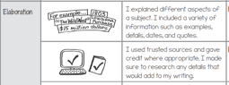  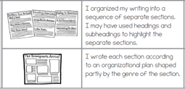  AE: Take some time right now and see what you’ll need to focus on for your writing. This checklist has a lot on it, so you may want to focus on structure first, and then use the convention section at the end. | Link: Make some notes on either a sticky note or on the bottom of your paper of what you want to work at getting better at. Maybe it’s organization:  Or maybe you are ready to elaborate and add more details to make your writing more interesting and a better teaching book? | Share: This is REALLY important work for you to do. Maybe you can look at another NF book and see how that author organized the text. Or you could look at how the author started the book or ended it.  You can also call a friend an take a picture of your writing with your phone and read it to your friend to get his or her feedback on how you could make it even better.  This is good work for you to do as you keep pushing forward with your work.
4-Writing with Specifics | Connection: “Today I want to teach you that, in information writing, perhaps more so than in any other genre, specifics matter. Expert writers know it’s not enough to writing, ‘Dogs eat a lot.’ Instead they write with specific: ‘Large dogs usually eat a cup and a half of kibble, twice a day. Smaller dogs eat far less, perhaps only half a cup twice a day. “ | Teach: Watch me show you how I can take a piece of writing, and check to see if it needs more specifics, and then add more detail.  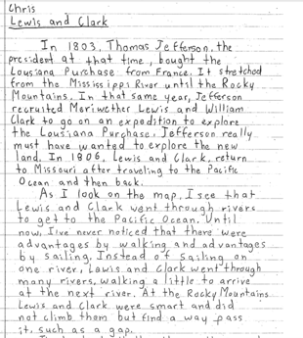 | 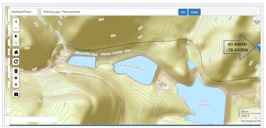  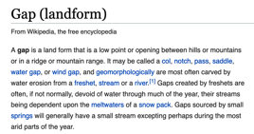 | AE: So now I’ll take that new detail and show you how I would simply add a bit more to give the readers better details as they read to learn. | Link: So take some time to reread what you have written so far in this chapter, and see if there are places where you can add more detail to make sure your writing contains the specifics it needs.  Off you go! | Share: As you move forward to write more chapters in your book, you’ll want to reflect on how things went with this chapter, onand think about how you’ll begin your other chapters. What have you learned? What will you look at as you revise and edit?  Keep writing!
5-Selecting Appropriate Content | Connection: Today… Writers give careful attention to the content they include in their pieces, deciding not only what should go in each section, but also what might be excluded. | Teach: Watch and listen as I read this section from a NF piece on soccer. See if you can find any information that could be either taken out or put into a different section. | 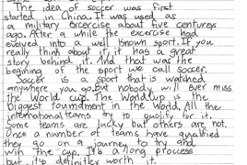 | AE: So as you look at your work today, reread what you’ve written carefully, and see if there is content anywhere that might not be necessary or in the wrong place | Link: You’re making good progress on your piece, you’re adding more details, taking out the content that might not fit, and you’re watching out to make sure you’re using conventions and good spelling!  Off you go! | Share: As you finish your writing today, work with a partner, or read to someone at home and get their feedback about all that you’re working on. You’re adding more details, taking out the content that might not fit, and you’re watching out to make sure you’re using conventions and good spelling!
6-Creating Cohesion Using Transition Words | Connection: Today… an important skill for information writers is to create cohesion across a piece of writing. Paragraphs, sections, or chapters-are like links in a chain. Each section of the text must be linked with the ones before it and the ones after it. Otherwise the chain, or cohesion will be broken. | Teach: Remember that transitions alone are not enough to create cohesion, the information needs to be logically ordered. Each part of the book should follow the section before it. | 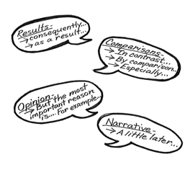  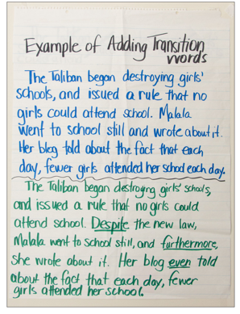 | AE: Look at your piece and check to see if the transitions create flow for the organization of the piece. Use our chart of transition words to see if you need to add any to make your writing organized and cohesive. | 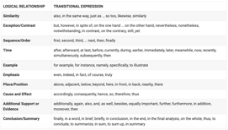  Link: Use the chart as you read and add any transitions that you need. | Share: As we wrap up today, look at the sections in your writing, and make sure that each section logically follows the sections that came before it, and that the transitions help put it all in order with cohesion.
7. Developing Text Features to Teach Information and Ideas | Connection: Writers, today…that text features are more than just pictures that go with the words on the page. Text Features can be used to teach additional information or convey information more quickly in a better format than words. | Teach: Remember in our last session, we read the piece about the Boston Massacre, and the depiction that Paul Revere crated to show the injustice, but not necessarily the way it actually happened? Well this picture would be good to include, and it would be hard to draw, but you can find it online and add it as a screen shot. | 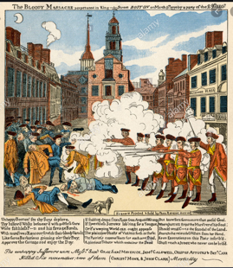  https://en.wikipedia.org/wiki/Boston_Massacre  But.. remember that if you take something offline, you’ll need to credit the source you used: | 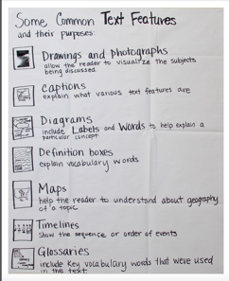  AE: Turn to a partner or reread your piece to determine where a text feature, like a picture, chart, map… might be helpful for adding a better understanding for your readers.  Text feathers can and should help increase the knowledge that you’re sharing with your readers. | Link: You’ll want to think about what the best text features might be to help with this. Too many might take away from your writing, so balance is a good thing to work toward. Take some time today to find or draw the right text features that will improve your piece. But… don’t spend the whole time on features, make sure you get some writing done as well! Off you go! | Mid TP- “Writers…remember that when you add in text features, they can help to clarify ideas, and not just facts. Remember Seymour Simon’s book on The Solar System, well he used this sketch to show how the sun impacts seasons, depending on where the Earth is in its rotation around the sun. This can be a hard concept to understand, but his picture helps the reader understand.  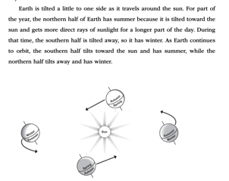
Day Number | Connection…  Teaching Point-Mini Lesson-  “Today I want to teach you…” | Teach  Watch Me As I…  Model the instruction you want them to use... | Mentor Texts & Chart or Materials | Active Engagement- Turn & Talk-  “Did you see how I just did that? Turn to your partner and….” | Link  Today we worked on…. So when you go off and read, try to…  “Off you go” | Mid Workshop & Share Session-  End of Workshop  “So our workshop for today is ending... Today we worked on…, this is important all of the time when you write informational topics….” Off you go!
 |  | Bend II: Using Brief Research to Supplement and Extend Books
8- Researching to Find New Information that Bolsters Writing  This session will need to be adapted based on the level of your kids and what work has been done on citing sources and bibliographies. | Connection: Sometimes as informational writers, we find ourselves asking questions that we can’t answer, so we must turn to research. Today I want to teach you that one way information writers set out to research is to think about kinds of research they need to do to find the information they need, such as interviewing an expert, using books or online sources, or creating a survey. They make smart decisions about what research makes sense for their project. | Teach: Watch me as I think about how and where to learn more about the history of pandemics in the world.  Remember that readers are more likely to use my ideas if I use reliable sources and bolster the ideas with concrete, statistics and facts.  Model how to search for more information, noting the online source and the url: .com, .net, .gov., .edu… | Model various web-searches and websites, noting the reliability of .gov or .edu  https://www.visualcapitalist.com/history-of-pandemics-deadliest/  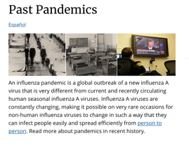  https://www.cdc.gov/flu/pandemic-resources/basics/past-pandemics.html  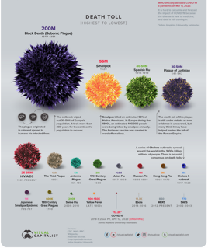  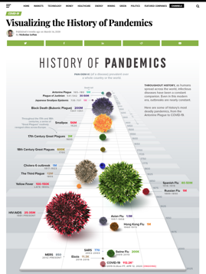 | AE: Notice how I looked out for things like ads, biased information, and the clarity of the information provided. The URLs that end in .gov are often reliable because they are from the government. Those that end in .com must be looked at carefully to determine who the authors are and to look for biased or misleading information. Sometime sites are really an advertisement to try to sell something. | Link: As you go off to write today, determine where you might need more specific information to add to your piece. If you are using online tools to search out more information, be careful to analyze the reliability of the information. Keep track of the URLs or the books you use to include the cites in your list of sources. | Possible Mid Workshop Teaching Point (MWTP)  -Writers, eyes on the screen as I show you how to analyze the hits that come up from your Google search to find the best sites to use for additional research…  Share Session  -Writers… turn to the person next to you and tell each other one site that you used to find additional credible information to add to your piece. How did you know it’s a credible site?  Possible Share:  Writers… let me show you how to site the sources you’re using to add to your pieces:  Possible Share:  Writers… I’m going to suggest that you get together with classmates who may have done some research on topics that are similar to yours. Please share the information you found and describe how you know it’s credible.
9- Quoting Experts  This lesson on citing sources might be skipped if it’s not what can be taught remotely. | Connection: Today… when writers are researching, they are on the lookout for ‘juicy quotes’ that they can incorporate into their writing, quotes that capture precisely what the writers are hoping to say or that support a fact or idea they’ve included in their writing. | Teach: Watch me as use some of the author’s words exactly as they appeared, using quotations around the words, citing the source, giving proper credit to the author.  “One way to identify expert testimonies you want to include is when you’re reading, you think, “That’s the perfect way to say that!”  When comparing the flu pandemic of 1918, to today this is a quote I might use:  “Massachusetts had been drained of physicians and nurses due to call for military service, and no longer had enough personnel to meet the civilian demand for healthcare during the 1918 flu pandemic” (CDC.gov., Apr. 2020). | 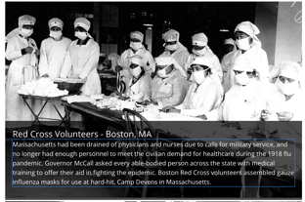  Notice in this brief note about the 1918 pandemic, there were similar problems with supplying that our country faced with this current pandemic.  An MLA document for MS kids on is posted on Padlet. You may have your own to use? | 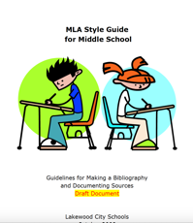  AE: As you’re writing today, you’ll want to provide some explanation about why the quotes are relevant and how they connect to your ideas about your topic. | Link: Remember that you’ll need to cite the sources you’ll use.  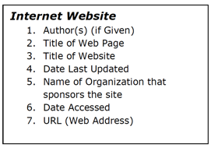  Centers for Disease Control and Prevention ,CDC.gov, April 2020, www.cdc.gov/ flu/pandemic-resources/basics/past-pandemics.html | Share: So let’s get together before we wrap up so I can show you how and why a quote might be helpful. As I’m writing about the history of pandemics, this section from the CDC talks about the need for PPE (Personal Protection Equipment)  The need for PPE (Personal Protection Equipment)  even though that’s not what they called supplies at that time, was also an issue in 1918 just as it is today. during the 1918 flu pandemic. “Governor McCall asked every able-bodied person across the state with medical training to offer their aid in fighting the epidemic. Boston Red Cross volunteers assembled gauze influenza masks for use at hard-hit, Camp Devens in Massachusetts” (CDC, 2020).  Now watch how I add the bibliographic entry for this quote.
10- Including Expert Language or Content Vocabulary | Connection: Today… that part of your job as an informational writer is to “talk the talk” of your topic. How can I teach others about this in ways that they will learn more than they already know so that they, too, can sound like an insider on the topic? | Teach: You want to teach others in a way that will help them learn more than they already know about the topic. You want to use technical vocabulary that will make you sound like an expert about the topic and inform others. Instead of blend in… camouflage. Instead of jaws of an insect… Mandibles | 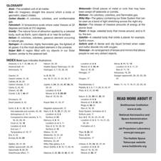  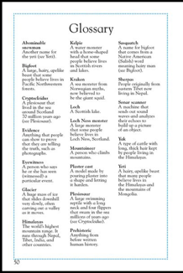  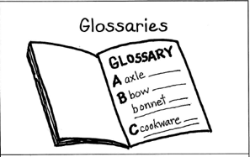 | AE: Turn to your partner and share some of the technical terms you have used in your writing, and listen to any suggestion that your partner might have for terms dealing with your topic. | Link: As you go off…. Here are some of the terms related to pandemics:  - Pandemic  - Epidemic  - H1N1  - SARS  - Influenza  - Mortality  - Disinfectant  Keep a list of the technical terms you use in your writing as you may want to put a glossary in the piece to define some terms for your readers. | Share: Take one or two of your expert words and prepare a sentence that you’ll recite out-loud for your partner. Your partner will guess what the word means, and you’ll then show where is lives in your writing. Take turns.  Remember that expert vocabulary is usually important enough to use throughout the piece!
11- Using Diagrams and Illustrations to Convey Information | Connection: Today…. That information writers look for opportunities to use a diagram or illustration from a source that would be just right in their own writing. Often this diagram will visually illustrate a larger point or idea that words alone cannot. If you use an image from another text, you must reference it and explain it. | Teach: Watch me as I share a few pieces of writing that shows how the diagrams and pictures make the writing stronger. | 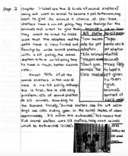  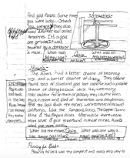 | AE: Pick up your writing and read a section to see if you might be wise to include a picture or diagram.  Remember… if you decide to put in an image from a online site or another document, you’ll need to site that source under the picture. | Link: So as you go off today, this is nearly the last day you’ll have for research as you’re writing. Use your time well and don’t waste a minute as you add more to make your writing great! | Possible Mid TP: Show how to do a screenshot on a computer and then cite the source.  Possible Share: For those who need it, show a small group how to paraphrase when you use information from a source.  Possible Share: Remember to keep an up-to-date list of the sources you’ve used so that you can create a bibliography at the end.
12. Self Assessing and Setting Goals | Connection: Today… that as you begin new sections for your writing, you need to remember to use all that we’ve worked on, and using the checklist to remind you of the qualities of informational writing that you’re working to include in your piece. | 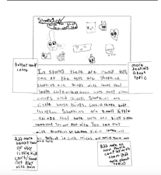  Teach: Let’s look at a piece of writing together, and notice how this writer reread their piece, and used sticky notes to set some goals of how he could improve his writing. | Writing Checklist:  Which Grade?  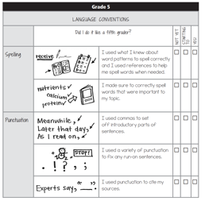  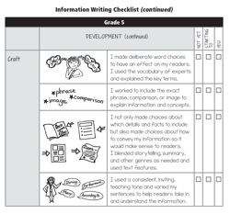 | AE: Turn to a partner or someone who might be able to read your work, and tell them what you feel that you’ve done well, and perhaps what you might need to improve. Setting goals is an important thing to do in all aspects of life, but especially in your writing. | Link: As you go off to self-assess, use a small sticky to set some goals of ways you can improve your writing, and then look back at some of the resources you have to improve your work. | Share:  Meet with a partner to share some of the things you did to improve your writing. Show the revisions you made!
Day Number | Connection…  Teaching Point-Mini Lesson-  “Today I want to teach you…” | Teach  Watch Me As I…  Model the instruction you want them to use... | Mentor Texts & Chart or Materials | Active Engagement- Turn & Talk-  “Did you see how I just did that? Turn to your partner and….” | Link  Today we worked on…. So when you go off and read, try to…  “Off you go” | Mid Workshop & Share Session-  End of Workshop  “So our workshop for today is ending.. Today we worked on…, this is important all of the time when you write informational topics….” Off you go!
 |  | BEND III: Using Mentor Texts to Lift Writing to the Next Level
13- Using Mentor Texts for Ideas on Presenting Information and Structuring Texts | Connection: Today I want to teach you that using mentor texts to see how author’s organize their writing is a good tool to help you know how you can structure your final piece. Another thing they can do is look at other NF books to see how other authors organized all of their informational elements in their books. | Teach: Watch me as I look at a few NF books to notice how they were put together to be published.  (Model with several appropriate and high-quality books)  Hmm… so this book about the solar system starts right with the facts. The first page is about the whole solar system… with facts about each planet on a separate page.  The book called Beastly Tales starts with a nice Table of Contents and shows how the content is laid out. It has some great text features right on that page too  Then, the section about The Loch Ness Monster starts with a story about when people spotted a huge beast in the Loch Ness, a lake near Scotland. So it’s narrative NF, but moves into expository  I notice how the story is about all of the sightings, facts, pictures and things that have been collected, but the structure of the text is narrative non-fiction. | 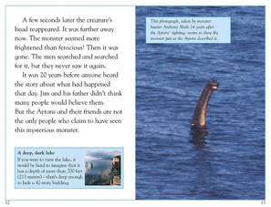  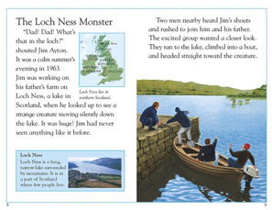  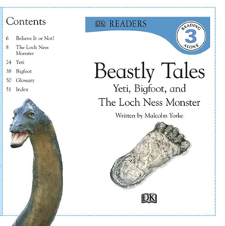  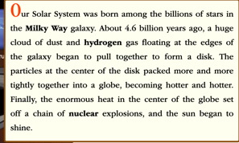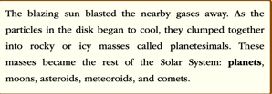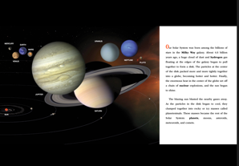 | 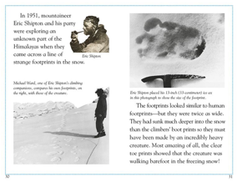  AE:  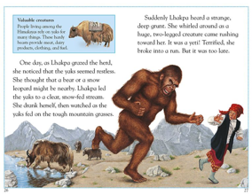  What I notice about the sections on the Yeti or Big Foot is that it’s also written in a narrative structure, that almost tells a story that includes the facts.  I also notice where they put the text features like the pictures and diagrams.  So… take a look at a few NF books that you have and notice all that the author did to put his book together. | Link:  So as you go off today, think about how you’ll present your work to the world. Do you have your Table of Contents organized to match the content of the piece? Are the text features the way you like them.  You’re presenting your work, and you’ll want to see what you can learn from other good NF authors. | Share: Tell you partner or someone at home about any changes or decisions you made regarding the structure of how you’ll put everything together for your book.
14-Analyzing Texts by Published Authors, Asking, “What Makes this Text so Effective at Conveying Information?” | Connection: Yesterday we noticed ways that published authors structured their info texts. Today we can study these texts with an eye on how these authors packed their texts with tons of great information. We can study our texts and ask: What makes this so effective at conveying information? | Teach: Listen to this section of a book by Melissa Stewart on Hippos:  “Hippopotamuses are usually gentle giants. During the day, they lounge and snooze in shallow water holes. At night, they lumber onto land and munch on grasses and leaves. But, if a boat gets between a hippo and the deep water or between a mother and her calf, the animal will panic. It may tip over the boat and attach the passengers with its powerful jaws.”  “Hmm… it’s almost like she’s written a setup sentence for readers- “Hippopotamuses are usually gentle giants”. She followed that with info that shows what she means by that. She used visual imager and strong descriptive words to convey facts in a powerful way. It’s expository writing, but the way she wrote it, it almost sounds like a story. |  | AE: Take a few minutes and choose a section from a NF book or article and read a portion out loud, noticing what the author did to make the writing effective. Do some inquiry work around some of writing from a mentor text and consider how it might impact what you do with your writing. Maybe you can use some of the techniques you see in their work. | Link:  Come together and list some of the things we noticed in the authors work:  -Expert Language  -Defining new words in text- appositives  -Formal style of writing  -Text Features  -Multi-media  - | Share:  This is the last day you have before we finish our books and “publish” them by finishing all you’ve done.
15- Readying Writing for Presentation | Connection: Can you imagine if a person who was trying to teach you something, and while they were explaining what they wanted you to learn, they had bad grammar, incomplete sentences, and you couldn’t really understand. Today I want to teach you that for information. For information writing to be most effective, it must be clear and free of errors. You’ll need to edit carefully to create paragraphs, use proper spelling, punctuation and grammar. | Teach: The Language section of the checklist is here, and you’ll use that section to check you work. | 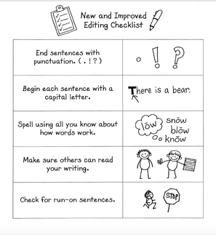 | AE:  As you go off today, you’ll spend the time editing and improving your writing so that you an share it tomorrow! | Link: Remember that it helps to read your work out loud, as this is how you’ll hear the mistakes that might need to be fixed. | Share: So.. you should all be feeling good about the writing you have worked so hard on! You all have a text that includes information based on. Your own expertise on the topic as well as information you’ve collected from research, text features, structures and craft moves that you may have tried for the first time. You have a new understanding of that makes a strong informational text.  Tomorrow, we’ll set up stations around the room and break the class in half to share and read other’s work!
16- Sharing Published Pieces with the World  Your sharing venues will depend on whether you are teaching remotely or not. If you are teaching remotely, you will need to differentiate to include everyone! | Connection: Today we’ll have an ‘expert fair’  Let’s put our desks into a square around the room, and half of you will sit on the outside of the square with your writing and any other artifacts you’d like to share. The other half of the class will be on the inside of the square, and they’ll have the chance to read, ask questions, offer feedback and give lots of compliments | Teach: The goal of this sharing is to make your writers fired up about being authors of informational text who have made great progress with informational writing. | Possible Ways to Share:  Posted pieces on:  -Google Classroom  -Book Creator  -Posts on Padlet  -Camera shots via email  -… | AE:  Teachers… you’ll use whatever sharing venue will work for you, especially if you are teaching remotely. | Link: Remind students to leave at least 3 compliments on classmates’ work. -Things they learned,  -things they noticed from text features  -things they noticed from the writing | Share: Allow students time to read and comment on other’s writing.

